Hotel Reservation System

1. Artifacts of the Requirements Gathering Workflow
(1)Vision Document

(2)SRS And Data Dictionary

(3) Initial Use Case Diagram
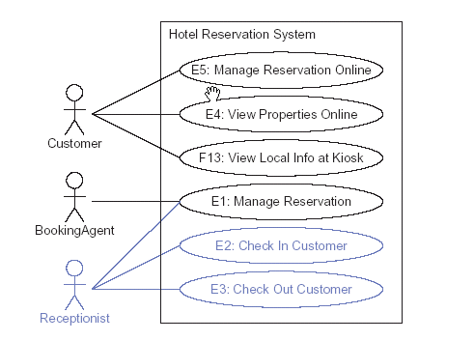
(4) Use Case Scenario Example

2. Artifacts of the Requirements Analysis Workflow
(1) Use Case Form

(2) Refined Use Case Diagram
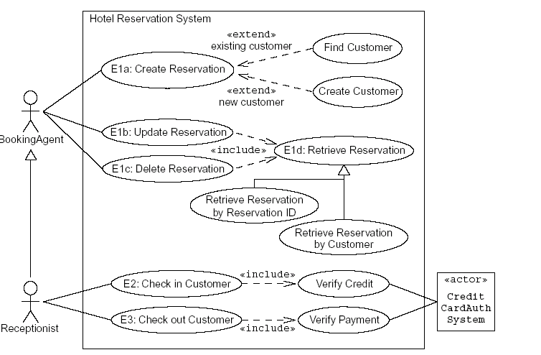

（3）.Activity Diagram Example
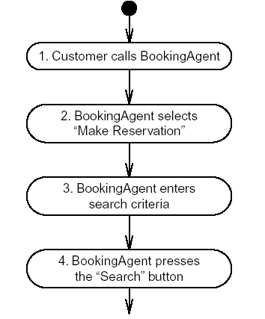

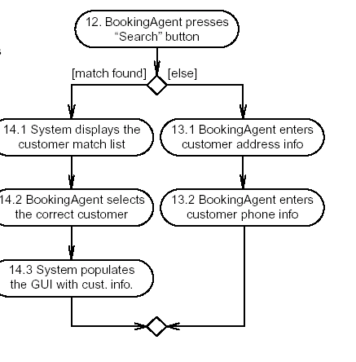
(4) Key Abstraction Form
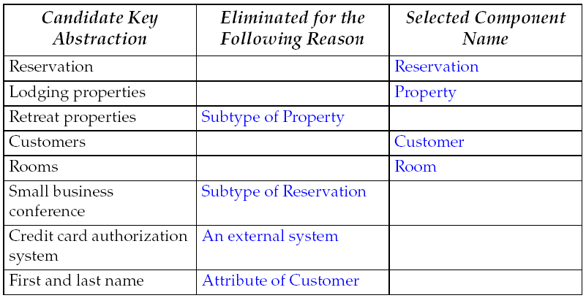
(5) Problem Domain
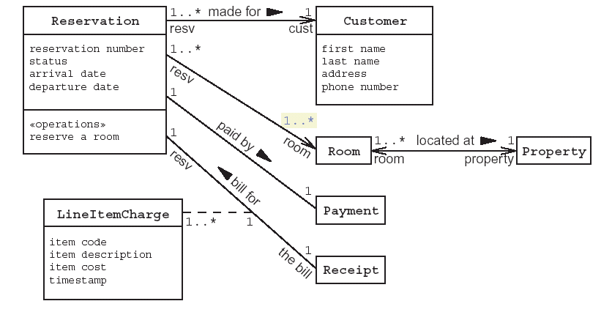

3. Artifacts of the Design Workflow
(1) Robustness Analysis
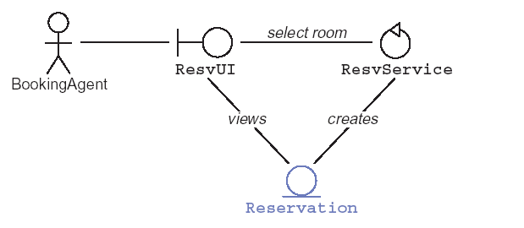
(2)Collabration Diagram
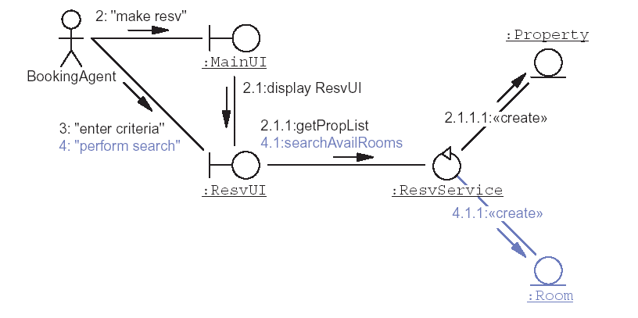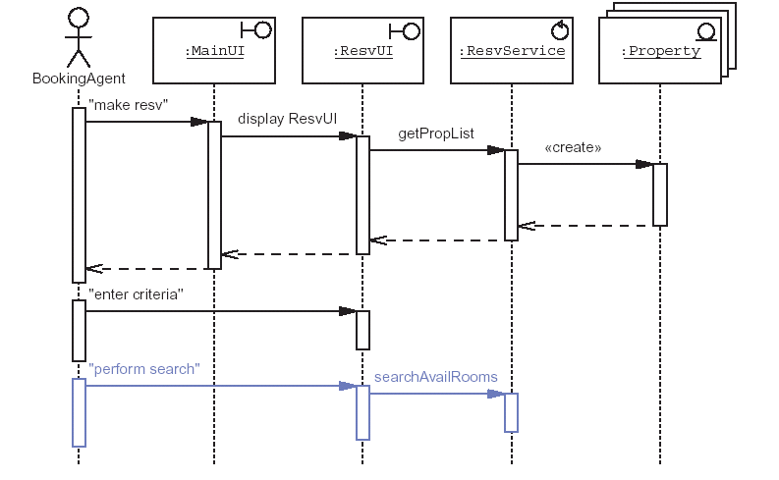

Refined Design Model ………
………….
…………………………

4. Solution Model

